DAY 2
Todays task is overlooking Apexa IQ website and going through Apexa YouTube channel.

Overview of the website :
Apexa iQ is a SaaS-based, agentless IT Asset Management and Cyber Asset Attack Surface Management platform that helps organizations discover, manage, and secure their IT asset
Providing complete visibility and security of IT assets.
Apexa iQ helps organizations:
- Discover all IT assets
- Identify vulnerabilities
- Detect obsolete systems
- Improve asset hygiene
- Calculate IT Risk Score
- Improve security posture
The platform provides:
- Centralized dashboard
- Asset inventory
- Risk and compliance monitoring
Apexa iQ Asset Management and Security Lifecycle
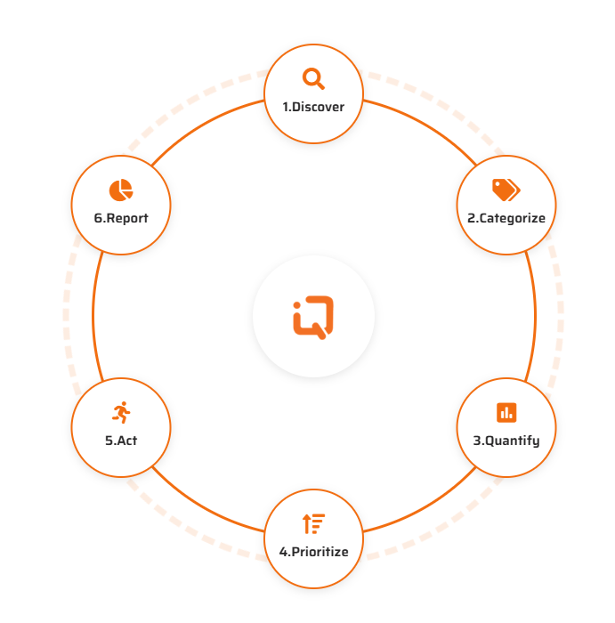

1. Discover
Apexa iQ finds all IT assets like laptops, servers, and cloud devices.
2. Categorize
Assets are organized based on type, importance, and function.
3. Quantify
Apexa iQ analyzes assets and measures risk, vulnerabilities, and security status.
4. Prioritize
High-risk and critical assets are identified and prioritized for fixing.
5. Act
Security issues are fixed by installing patches, updating software, and improving configuration.
6. Report
Apexa iQ generates reports showing asset status, risk score, and security posture.

Q) What is Shadow IT Asset
Shadow IT assets are devices, software, or cloud services that are used in an organization without the knowledge or approval of the IT or security team.
These assets are not officially managed or monitored.

Example related to Apexa iQ
Apexa iQ detects shadow IT by discovering:
- Unknown devices
- Unauthorized software
- Unmanaged cloud assets
Example:
Unknown laptop detected → flagged as shadow IT asset

Q) What is complaint and non complaint
Compliant means a system, device, or software follows all required security policies, standards, and rules.
It meets security and compliance requirements.
Non-compliant means a system or device does not follow required security policies or standards.
It has security risks.

SOLUTIONS
BY INDUSTRY
1. Financial Services and Banking
Use of Apexa iQ to manage and secure IT assets in banks and financial institutions to protect sensitive financial data.
2. Healthcare
Use of Apexa iQ to protect patient data, medical systems, and healthcare IT infrastructure.
3. Insurance
Use of Apexa iQ to secure insurance company systems, customer data, and ensure compliance.

BY USE CASE
4. Comprehensive Asset Inventory Management
Maintaining a complete and accurate list of all IT assets like laptops, servers, and software.
5. Risk Reduction at Scale
Reducing cybersecurity risks across the entire organization efficiently.
6. Continuous Audit Readiness
Ensuring systems are always prepared for security audits and compliance checks.
7. Optimal IT Service Delivery
Improving IT performance and ensuring smooth and efficient IT services.
8. Clean Data for a Competitive Edge
Maintaining accurate and reliable asset data to make better business and security decisions.
9. Maximized Technology Spending
Ensuring technology investments are used efficiently without wasting money on unused or duplicate assets.

FOR MSPs
10. MSP (Managed Service Provider)
Companies that use Apexa iQ to manage and secure IT systems for their clients.

CYBER INSURANCE
11. Beazley
A cyber insurance company that uses Apexa iQ data to assess cybersecurity risk and provide insurance coverage.

YOUTUBE VIDOES
It's called Apexa I.Q. Apexa software is built BY I.T. leaders FOR I.T. leaders.
Lokesh Aggarwal: When we started this company, I wrote one word on the board. The word was Simplicity. I come from the other side. I know what CIOs and CTOs and IT managers, they don't want. I've been in their shoes. Apexa is easy to Implement. Easy to use. Easy to manage.
Apexa is easy to Implement. Easy to use. Easy to manage.
VIDEO-1
Mitigating Risk and Streamlining Operations: Reducing Technical Debt in Banks with Asset Assurance(https://youtu.be/zccCnnj1hTI?si=j2BMZG0HqyBWSKMH)
Introduction
- Banks and financial institutions manage thousands of IT assets.
- Many assets become outdated, unmanaged, or vulnerable over time.
- This creates technical debt, which increases cybersecurity risks and operational complexity.
What is Technical Debt in IT Assets
- Technical debt refers to outdated systems, obsolete software, and unmanaged assets.
  - Security vulnerabilities
  - Compliance issues
  - Increased operational cost
  - Reduced efficiency
Role of Asset Management APEXA IQ
- Discovering all IT assets automatically
- Identifying vulnerabilities and obsolete systems
- Providing asset inventory and risk analysis
- Improving asset hygiene and compliance
- Reducing cybersecurity risks

APEXA PILLARS
1)INVENTORY
2)SECURITY
3)PRODUCTIVITY
4)FINANCE

VIDEO-2 (https://youtu.be/qj_G5IUlpa8?si=MJgDc9sqKaJIWRgW)
Q)what are audits
An audit is a systematic process of examining and evaluating systems, assets, or processes to ensure they follow security policies, standards, and regulations.
It checks whether everything is secure, compliant, and working properly.
Why audits are done
- Check security status
- Ensure compliance with standards (ISO 27001, HIPAA, etc.)
- Identify vulnerabilities
- Improve system security
Types of audits
1. Security audit
Checks cybersecurity and vulnerabilities.
2. Compliance audit
Checks if systems follow standards like ISO 27001.
3. IT audit
Checks IT systems, assets, and controls.
4. Internal audit
Done by organization itself.
Apexa iQ helps auditors
- Provides complete asset inventory in one place
- Shows compliance and non-compliance status of devices
- Detects and reports vulnerabilities automatically
- Generates audit-ready reports and evidence(such as history of system status and patch)
- Saves time by reducing manual data collection
- Ensures systems are continuously audit-ready(continuous monitoring )

